Great tools you can use for your Agile Projects
Here is a list of great tools which you can use for your Agile projects. Many of them are completely free! Click on the image and you will be taken to each tool.

Jira
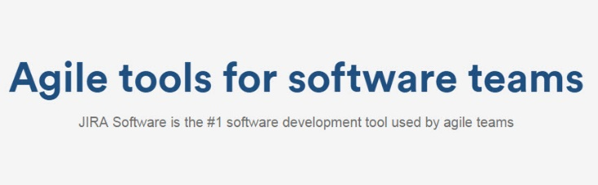

Trello
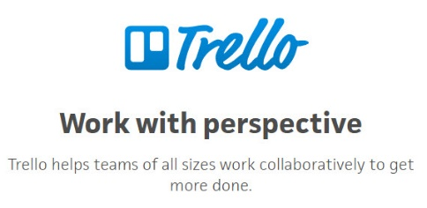

Freedcamp
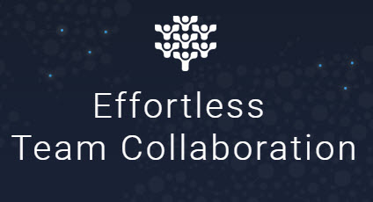

Asana


Basecamp
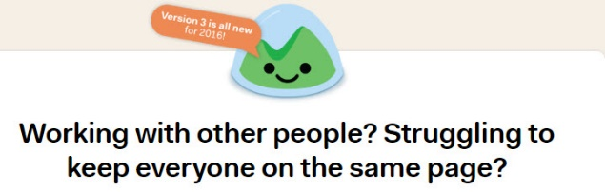

Active Collab


Workamajig


Teams

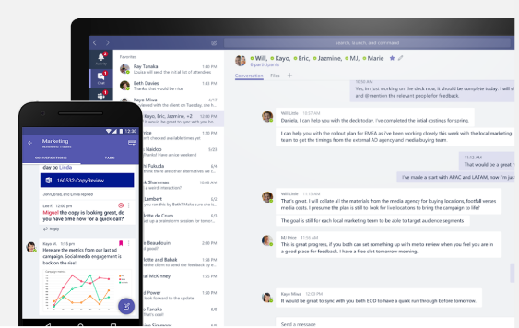​

​

Planner​


